Lab NO 4

Objective: To learn report generation in OLTP systems

Customer Table

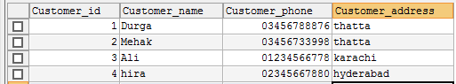

Expenditure



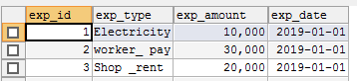

Product Table

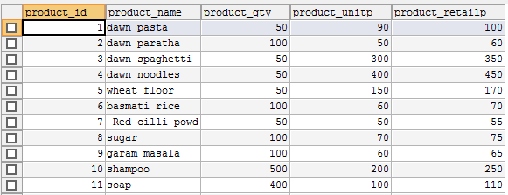

ORDER



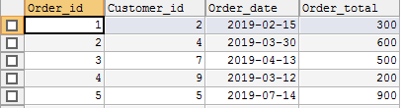

***Stored procedure*** *contains following queries:*

1. ***Total sales in a month*** *(Use only order table).*
2. ***Profit/loss in a month*** *(Use product (to account for purchasing costs), expenditure as well as order tables).*
3. ***Highest selling product of the month*** *(By highest sold quantity*)
4. ***Lowest selling product of the month*** (*By lowest sold quantity*)

